

**Our Ladys RC Primary School**

**FOOD AND FITNESS POLICY**

**Food and Fitness Policy**

**1. Introduction:**

At Our Ladys RC Primary School we are committed to encouraging our pupils to lead active and healthy lifestyles. We believe that healthy children are best able to take full advantage of the educational opportunities that the school provides. The partnership of home and school is critical in shaping how children and young people behave, particularly where health is concerned. We encourage a whole school community approach to food and fitness. The Headteacher, staff and governing body will do their best to ensure that food provided in the school and advice given to pupils promotes healthy and active lifestyles in line with Welsh Government and Public Health Wales guidance.

The Welsh Government is determined to help secure, maintain and improve the health of young people with the introduction of **The Healthy Eating in Schools (Nutritional Standards and Requirements) (Wales) Regulations 2013.** Food and drink served in local authority maintained schools must meetThe Healthy Eating in Schools Regulations. These Regulations are part of the wider **Healthy Eating in Schools (Wales) Measure 2009** and are based on the previous Appetite for Life Guidelines. These all set out to improve the nutritional and food standards of the food and drink provided in schools in Wales.

The Well-being of Future Generations (Wales) Act 2015 has at its core an intention to improve the health, social, economic, environmental and cultural well-being of Wales. Promoting healthy diets and increasing levels of physical activity will be a key component of achieving the ambitions within this Act. We believe that physical activity, from the very earliest years, is essential to ensure healthy growth and development, as well as being linked to better academic achievement. In relation to the new Curriculum for Wales, we are committed to ensuring that our school creates healthy, confident individuals in the coming years by addressing our pupils’ physical needs alongside their academic needs. We intend to include more physical activity to the school day by developing physical literacy skills and encouraging physical activity during break times, along with physically active learning methods within lessons.

* 1. Our school's policy on food and fitness has been created in line with guidance from the following documents:
* The Healthy Eating in Schools (Nutritional Standards and Requirements) (Wales) Regulations 2013.
* Personal and Social Education Framework for 7 to 19-year-olds.
* The Foundation Phase Framework for Children’s Learning for 3-7 year olds in Wales: Personal and Social Development, Well-being and Cultural Diversity.
* Curriculum for Wales: Health and Well being Area of learning experience.
* Healthy eating in maintained schools statutory guidance for local authorities and governing bodies. Guidance document no: 146/2014.
* National Curriculum for Wales, Design and Technology, Physical Education, Science (2008).
* Getting Wales Moving, a joint report by Public Health Wales and Sports Wales 2017.
* Healthy Weight: Healthy Wales, Welsh Government 2020.
* United Nations Convention on the Rights of the Child (UNCRC).

**1.2** This Policy was created/reviewed following **consultation** with staff, pupils, governors and the Cwm Taf Morgannwg Healthy Schools Team.

**2. Links with other policies:**

This policy should be read in conjunction with the following school policies:

* Personal and Social Education (PSE) / Health and Wellbeing
* Physical Education
* Hygiene
* Health and Safety
* Equality Information and Objectives

**3. Aims:**

* To develop a whole school approach to food and fitness through a policy that offers a shared vision, coherence in planning and development, and consistency in the delivery of services, curriculum messages and the supporting environment.
* To improve the health of the whole school community by equipping pupils with the knowledge and skills to establish and maintain life-long active life-styles and healthy eating habits.
* To ensure that food, nutrition and physical activity become integral to the overall value system of the school and a common thread of best practice runs through the curriculum, the school environment and links with the wider community.
* To promote pupil participation and decision making in all aspects of food and fitness activities.
* To fully uphold the Rights of the Child with specific reference to Food & Fitness:  
    
  ‘Article 24: You have the right to have clean water, nutritious food, a clean environment and good healthcare when you need it.’

‘Article 31: You have the right to relax and play and take part in activities like sports, arts, music and drama.’

## 4. Objectives:

* To ensure that activities related to food and fitness provided for pupils throughout the day are inclusive and consistent with curriculum guidance and Welsh Government regulations.
* To work in partnership with School Meal Providers to ensure that consistent messages about nutritional standards and healthy lifestyles are given to our pupils.
* To offer a broad range of inclusive, safe, stimulating indoor and outdoor sports, play and recreational activities to continually develop physical literacy levels.
* To offer a range of inclusive safe practical cookery activities to continually develop a lifelong love of food and cooking.

## 5. The Welsh Network of Healthy Schools Schemes

Our school participates in the Welsh Network of Healthy School Schemes. As participants in this scheme, we aim to actively promote and protect the physical, mental and social well-being of our school community through positive action by such means as policy, strategic planning and staff development with regard to its curriculum, ethos, physical environment and community relations. We therefore aim to develop and implement a coherent health education curriculum in relation to food and fitness.

**6. Management and Organisation of Food and Fitness:**

**6.1 Role of the Governing Body:**

The role of the governing body for our School is to ensure that:

* The School Meal Service comply with the Healthy Eating in Schools (Nutritional Standards and Requirements) (Wales) Regulations 2013.
* Systems are in place to inform families of their entitlement to free school meals.
* The school is delivering a broad and balanced cross curricular programme of food and fitness to all pupils.
* Consistent messages are promoted through the formal and informal curriculum.
* A member of the governing body will be nominated to oversee the implementation of the Food & Fitness policy.

**6.2 Role of the Headteacher and Senior Leaders:**

**The Head Teacher and Senior Leaders will ensure that:**

* The school ethos and environment reflect the school policy.
* School Meal Service comply to current Healthy Eating in Schools (Nutritional Standards and Requirements) (Wales) Regulations 2013.
* Parents/carers are made aware of their entitlement for their child to receive free school meals as appropriate.
* All staff promote healthy eating and participation in physical activity in accordance with school guidance.
* There is adequate training and resources for staff involved in the delivery of the aims and objectives of the school’s Food and Fitness policy.
* A planned and appropriate food and fitness curriculum is provided for all pupils throughout the school year.
* The school does not advertise branded food and drink products on school premises, equipment or books and will ensure that any collaboration with business does not require endorsement of branded or specific company products high in fat, sugar or salt.
* Updates on school Food and Fitness actions will be included in the Annual Report to parents.

**6.3 All teaching and non-teaching staff to ensure that they:**

* Act as positive role-models.
* Ensure consistent messages are provided/ mixed messages are avoided in relation to diet, oral health and physical activity.
* Support implementation of the school policy.
* Deliver effective food and fitness education as agreed in this policy.
* Encourage participation in local and national initiatives.
* Promote healthy eating and active lifestyles in accordance with school guidance.
* Help and encourage children to select balanced food choices at lunchtimes and promote opportunities for them to be physically active during the school day**.**

## 6.4 The role of parents and carers:

We ask that Parents/Carers endeavour to:

* Support the policy.
* Provide healthy packed lunches if food is brought in from home.
* Apply for their child’s Free School Meals if entitled to do so.
* Provide fresh fruit and/or vegetables for snack.
* Provide a clean drinking water bottle for fresh, plain water only.
* Supply an appropriate PE kit as per school uniform policy.
* Ensure timely payment for school meals and snack provision if applicable.
* Support local and national initiatives.

**7. Curriculum**

## The Food and Fitness curriculum will ensure that;

* Pupils are taught to understand the relationship between food, physical activity and short and long term health benefits.
* Pupils will be given the opportunity to examine the influences of food choices, including the effects of the media through advertising, marketing, labelling and packaging of food.
* Pupils are provided with consistent key messages for good oral health.
* Pupils are given the opportunity to learn about the growing and farming of food and its impact on the environment both in the classroom and outside in the countryside.
* The out of school hours programme includes a broad range of purposeful and enjoyable food and fitness based activities.
* A well planned programme of study in PE that makes good opportunities for cross curricular promotion of physical activities and its relationship to diet and nutrition.
* 2 hours of quality PE will be provided per week for every pupil.
* All teaching and learning resources reflect current local and national guidance.

**7.1 Content of the Food and Fitness programme:**

The following tables provide a breakdown of what pupils should be given the opportunity to understand and learn during the Foundation Phase and Key Stage 2 with regard to food and nutrition. Please refer to the PE Policy for the breakdown of the programme of study for PE.

|  |  |  |
| --- | --- | --- |
| **What matter statement** | Developing physical health and well-being has lifelong benefits  *This Area can help learners to understand the factors that affect physical health and well-being.*  *This includes health-promoting behaviours such as physical activity, including but not limited to sport;*  *balanced diet; personal care and hygiene; sleep; and protection from infection.*  *It also includes an understanding of health-harming behaviours.* | |
| **Progression Step** | **1:** | I am beginning to make connections between my diet and my physical health and well-being. |
| **2:** | I have developed an understanding that I need a balanced diet and I can make informed choices  about the food I eat and prepare to support my physical health and well-being. |
| **3:** | I can explain the importance of a balanced diet and nutrition and the impact my choices have on  my physical health and well-being.  I can plan and prepare basic, nutritious meals. |

|  |  |  |
| --- | --- | --- |
| **What matter statement** | Developing physical health and well-being has lifelong benefits  *This Area can help learners to understand the factors that affect physical health and well-being.*  *This includes health-promoting behaviours such as physical activity, including but not limited to sport;*  *balanced diet; personal care and* hygiene; sleep; and protection from infection.  It also includes an understanding of health-harming behaviours...  *Learners will be encouraged to develop the confidence, motivation, physical competence,*  *knowledge and understanding that can help them lead healthy and active lifestyles which*  *promote good physical health and well-being.* | |
| **Progression Step** | **1:** | I have the confidence and motivation to move in different ways and I am beginning to develop  control of gross motor and fine motor movements in different environments, moving safely in  response to instructions. |
| **2:** | I can use and improve basic movement skills in familiar and unfamiliar situations.  I can respond to prompts in imaginative and creative ways.  I have the confidence and motivation to persevere when faced with physical challenges. |
| **3:** | I can develop and apply a range of skills in familiar, unfamiliar and changing situations,  exploring space creatively in response to a variety of stimuli.  I can motivate myself to engage confidently in regular physical activity and sport,  and am aware of my own progress. |

**8. Informal Curriculum**

Our school recognises the significant impact of the informal curriculum on the personal, social and emotional education of pupils as well as their physical health and wellbeing. Therefore Food and Fitness themes will be promoted through the informal curriculum which encompasses the values and attitudes promoted within the school, the physical environment and setting of the school.

We will also engage with pupils where appropriate in consultation on food and fitness related activities through groups such as the School Senedd, Health and Welbeing Cabinet, Playground Leaders.

**8.1 School meals and food provision**

* All school meals should comply with The Healthy Eating in Schools (Nutritional Standards and Requirements) (Wales) Regulations 2013.
* School menus and allergen information are clearly displayed around the school and canteen.
* We will provide an enjoyable dining experience by developing welcoming aspects of the dining room environment including displays of food, promoting healthy eating, availability of free water and organising appropriate queuing arrangements.
* Healthy options are promoted which give pupils the opportunity to try new foods.
* The regulations are in place for all food provided on the premises from 8am up to 6.00pm.
* Our school uses non-food rewards such as praise, stickers, certificates and dojo points rather than confectionary.
* As a school we ask that birthday cake and sweets/chocolate are not brought into school. Birthdays will be celebrated in class.

**8.2 Free School Meals**

1. Parents/carers are sent regular reminders to ensure that they are made aware of their potential eligibility for their child to receive free school meals, and reassured about how the system works at school.
2. The uptake of free school meals is considered a key indicator for school performance.
3. Steps are taken to protect the identity of pupils receiving free school meals.

## 8.3 Healthy Lunchboxes

* Current national guidance is provided for parents on nutritionally balanced packed lunches.
* Children are educated on the content of a healthy packed lunch.
* Healthy packed lunches will be promoted for school trips.

**8.4 Healthy Breakfast Club**

* The school has a Welsh Government Free Breakfast Club running providing nutritionally balanced food.
* The Breakfast Club provides pupils with the opportunity to participate in active play/ physical activity.

**8.5 After School Cooking Clubs**

* The school has offered an after school cooking club for pupils in years 3,4,5 and 6 in rotation.
* A member of staff has received Food Safety Level 2 Training which is updated every 3 years.
* Relevant staff have attended cookery skills training.
* Recipes are in keeping with Healthy Eating in Schools guidance.

**8.6 After School Clubs to promote physical activity and sport**

Our teaching Staff are committed to delivering afterschool clubs weekly. We also work in partnership with outside agencies and the Local Authority:

Partners include:

* RCT Sports / Fit4Fun.
* A variety of clubs will be provided throughout the year.
* Clubs on offer will be determined by the pupil choice.
* The school engages with members of the local community and parents/carers to assist where appropriate.

**8.7 Fruit Tuck Shop**

* The school has set up a weekly Fruit Tuck Shop, which pupils help to run.
* Only fresh fruit and vegetables are served. Crisps and confectionary will not be sold in school.
* The School Senedd / Health and Wellbeing cabinet are consulted in decisions to support the Fruit Tuck Shop.

**8.8 School Milk**

* Free semi skimmed milk is offered to all Foundation Phase pupils each day.
* Refrigerators are cleaned daily and temperatures are recorded.

**8.9 Drinking Water**

* Children and staff have access to free fresh, clean water throughout the school day in places other than in the school toilets.
* The school promotes ‘Water Bottles in Class’.
* If brought in from home, parents will be responsible for the hygiene of the bottles.
* If provided by school, designated staff members will be responsible for the hygiene of the bottles.

**8.10 Physical Activity**

The school acknowledges and will ensure that:

* Physical activity and active play is inclusive.
* Play leaders will be selected and trained annually to organise games and activities at break times.
* Families are encouraged to actively travel to school.
* Opportunities for additional physical activity will be incorporated throughout the school including, daily mile, class exercises,. standing activities, outdoor learning.
* Sports day is held annually.
* The playground is ‘zoned’ into different activity areas to encourage all pupils to participate in activity during break and lunchtimes that is suitable to their ability.

**8.11 Oral Health**

* The school actively promotes oral health messages through the curriculum.
* The school actively participates in Designed to Smile and facilitates oral health promotion to children and parents.
* The school advises its pupils and parents/carers to visit a dentist on a regular basis.

**8.12 Fundraising, social events, staff meetings and parents’ evenings**

* A selection of healthy eating options in keeping with The Healthy Eating in Schools (Nutritional Standards and Requirements) (Wales) Regulations 2013 will always be available during school fund raising, social events, staff meetings and parents evenings.
* Fundraising events which promote physical activity are encouraged.
* The school will ensure that any collaboration with businesses does not require endorsement of branded or specific company products high in fat, sugar or salt.
* Alcohol will not be used as part of fund raising including prize draws, raffles, hampers or during social events.

**9. Review, evaluation and dissemination:**

* Implementation of this policy will be monitored by the Headteacher and members of the governing body.
* It will be ratified every two years but reviewed annually or earlier if necessary.
* The School Senedd are actively involved with the implementation and review of this policy.

Aspects of this Policy will be replicated in the School Prospectus, Hwb+, shared areas on the school network and staff handbook. Parents may request a paper copy of the Policy from the school.

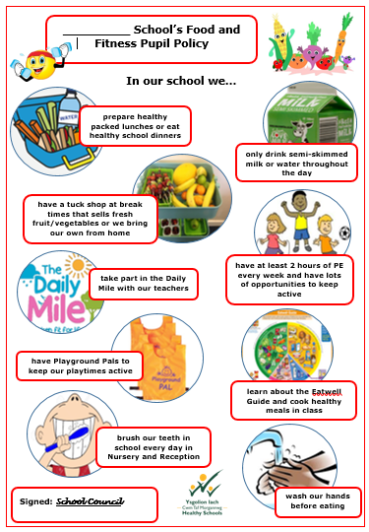**Appendix 1 – Example of a pupil friendly Food and Fitness Policy**

**Appendix 2 – Eatwell Guide**

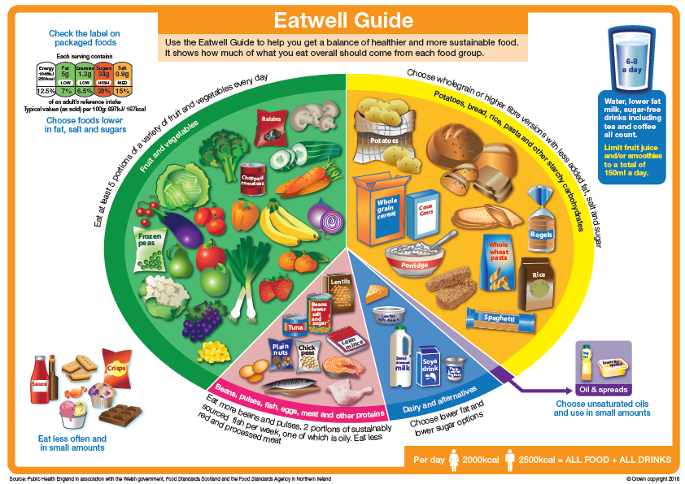

**Appendix 3 – Welsh Government Healthy Lunchboxes**

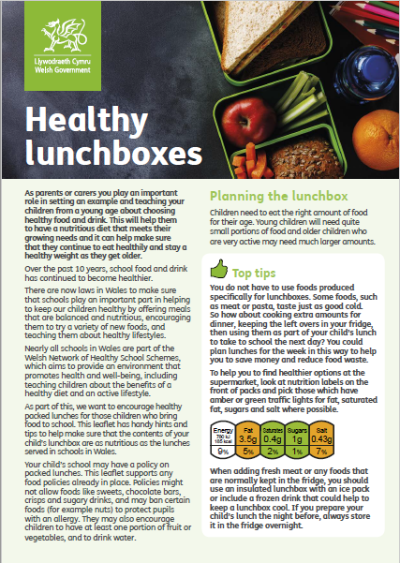

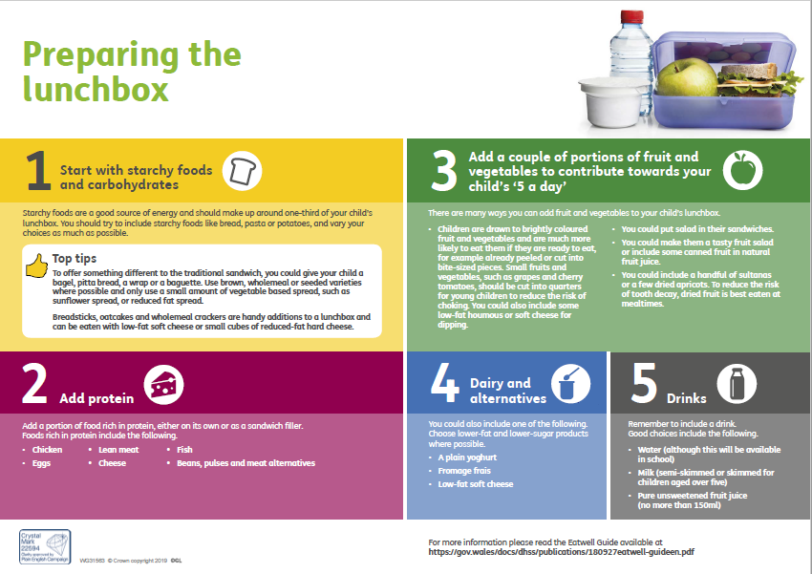

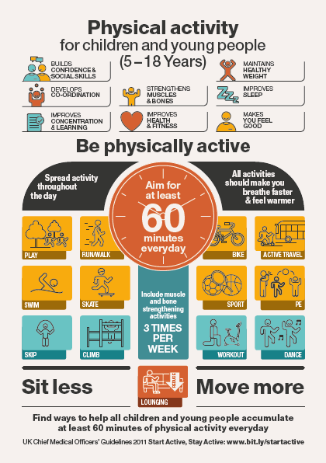**Appendix 4 – Physical Activity Guidance for 5-18 year olds**

**Appendix 5 – Food and Fitness within the New Curriculum for Wales 2022**

**Topic: Food and Nutrition  
Area of Learning and Experience:** Health and Well-being

|  |  |  |
| --- | --- | --- |
| **What matter statement** | Developing physical health and well-being has lifelong benefits  *This Area can help learners to understand the factors that affect physical health and well-being. This includes health-promoting behaviours such as physical activity, including but not limited to sport; balanced diet; personal care and hygiene; sleep; and protection from infection. It also includes an understanding of health-harming behaviours.* | |
| **Progression Step** | **1:** | I am beginning to make connections between my diet and my physical health and well-being. |
| **2:** | I have developed an understanding that I need a balanced diet and I can make informed choices about the food I eat and prepare to support my physical health and well-being. |
| **3:** | I can explain the importance of a balanced diet and nutrition and the impact my choices have on my physical health and well-being.  I can plan and prepare basic, nutritious meals. |
| **4:** | I can apply my knowledge and understanding of a balanced diet and nutrition to make choices which will allow me to maintain my physical health and well-being.  I can plan and prepare a variety of nutritious meals. |
| **5:** | I can adjust my diet in response to different contexts and apply my knowledge and understanding of a balanced diet and nutrition to support others.  I can apply a range of techniques to prepare a variety of nutritious meals. |

**What are the range of experiences and activities that can support learners to enjoy lifelong physical activity and care for themselves and others?**

*Learners should be supported to develop positive behaviours in their wider physical health and well-being. This could relate to a range of factors, including diet, substances, hygiene, infection, the physical environment, sleep and rest. Settings, schools and practitioners should consider what experiences will support learners to understand how these factors can influence their health and well-being, develop the skills to support healthy behaviours relating to these factors, and the confidence and motivation to support those behaviours for life. For example, developing skills to support a healthy balanced diet should consider how learners can develop the skills and the enjoyment of preparing food which forms part of a healthy balanced diet.*

**Topic: Physical Activity   
Area of Learning and Experience:** Health and Well-being

|  |  |  |
| --- | --- | --- |
| **What matter statement** | Developing physical health and well-being has lifelong benefits  *This Area can help learners to understand the factors that affect physical health and well-being. This includes health-promoting behaviours such as physical activity, including but not limited to sport; balanced diet; personal care and* hygiene; sleep; and protection from infection. It also includes an understanding of health-harming behaviours...  *Learners will be encouraged to develop the confidence, motivation, physical competence, knowledge and understanding that can help them lead healthy and active lifestyles which promote good physical health and well-being.* | |
| **Progression Step** | **1:** | I have the confidence and motivation to move in different ways and I am beginning to develop control of gross motor and fine motor movements in different environments, moving safely in response to instructions. |
| **2:** | I can use and improve basic movement skills in familiar and unfamiliar situations.  I can respond to prompts in imaginative and creative ways.  I have the confidence and motivation to persevere when faced with physical challenges. |
| **3:** | I can develop and apply a range of skills in familiar, unfamiliar and changing situations, exploring space creatively in response to a variety of stimuli.  I can motivate myself to engage confidently in regular physical activity and sport, and am aware of my own progress. |
| **4:** | I can transfer a range of movement skills from familiar to unfamiliar and changing situations and environments, using space creatively in response to a variety of stimuli.  I can engage in regular physical activity and sport with confidence, motivation and commitment. |
| **5:** | I can independently adapt and apply movement skills across a range of activities and environments, managing space creatively in response to a variety of stimuli.  I can value the benefits of participation in regular physical activity and sport, seeking opportunities to develop my expertise. |

**What are the range of experiences and activities that can support learners to enjoy lifelong physical activity and care for themselves and others?**

*Positive learning experiences can support learners to value physical activity, including sport, which in turn can motivate them to lead physically active lives. Learner-centred pedagogies such as purposeful play, a multiskills approach, the Teaching Games for Understanding (TGfU) approach and the Sport Education Model (SEM) can all contribute to a learning culture where physical activity is enjoyed by all. Learners should also be supported to value the benefits of this, including social, recreational and performance aspects, as well as how it supports their physical health and well-being. These activities should also support the development of knowledge, understanding and transferable skills within and beyond the physical health element of this Area. Settings and schools should consider how opportunities, experiences and pedagogies, including participation in various sports and activities, support the development and refinement of gross motor**and fine motor movements, transferable skills and the ability to connect progress with perseverance and confidence. Realising progress in physical competence supports learners’ motivation to persevere and supports their confidence to continue participating throughout life.*